Key & Chemistry

Christopher Guzowski

**Game Pitch**

Falling through what feels like a dream.. you unite with the floor like never before! You feel like that actually made you smarter as you start to recall your previous life as a chemist. Test your patience and knowledge against these puzzles!

**Objectives**

I expect the players to gain some knowledge on physics and chemistry, while having a good time traversing the game. There are a lot of jokes and funny pictures / videos / sounds for players to be surprised by.

**Controls**

Mainly players will use the navigator buttons and commands, you don’t need to type to beat but it’s available if you so choose to challenge your patience even further.

**Gameflow**

You start in a room with a few objects, these objects when used wisely will give you access to room(s). Unlocking rooms gives you potential to unlock other rooms. At the end you will meet face to face with your ultimate challenge, a chest and this time you’ll need to use logic in a different way.

**Screenshots**

**The beginning you’re falling.. and what happens if you take 1 too many rocks**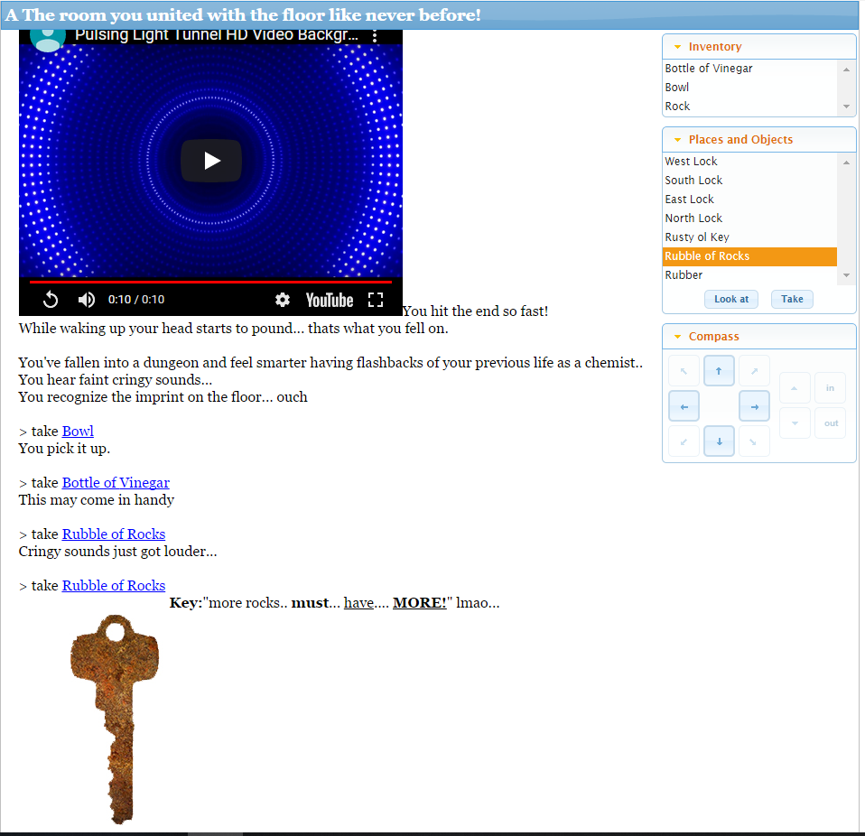

**After you see the key visible and take it**

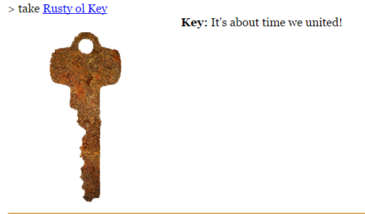

**After using bottle of Vinger on Rusty ol Key In Bowl**

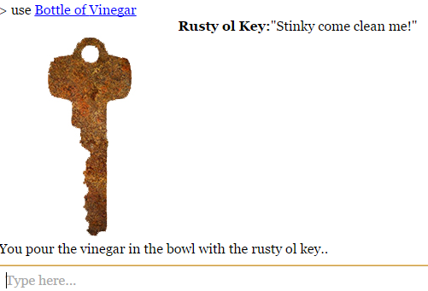

**After key / cold key used on north lock**

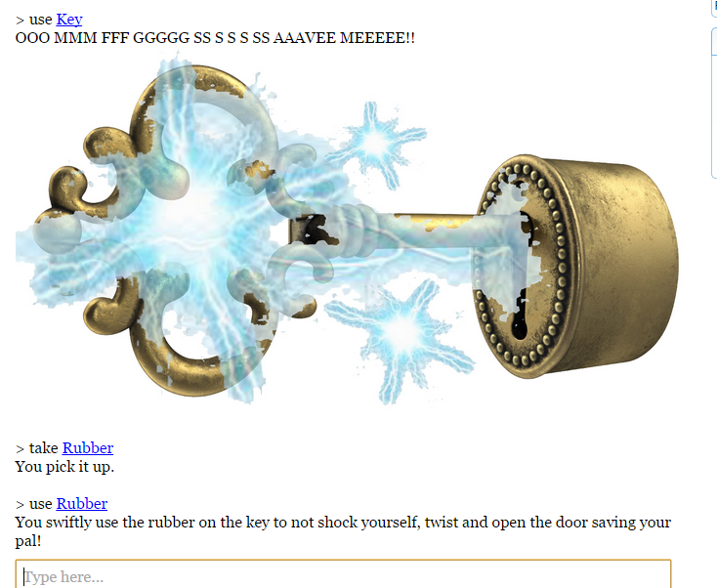

**After Canister is used on Key in bowl**

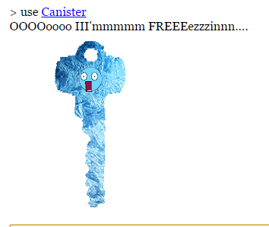

**After you hit hammer on rock and successfully produce spark**

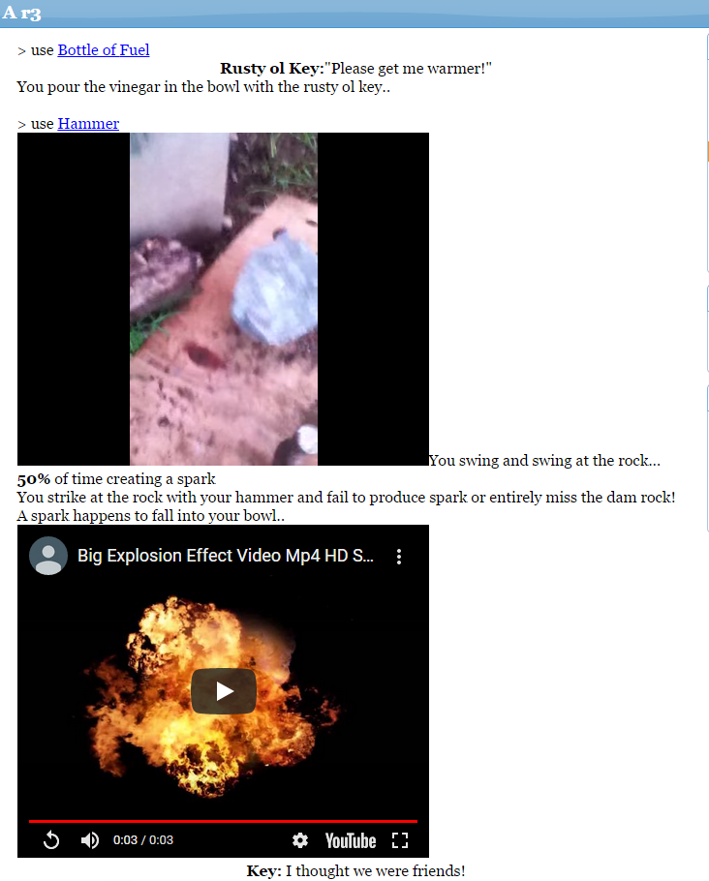

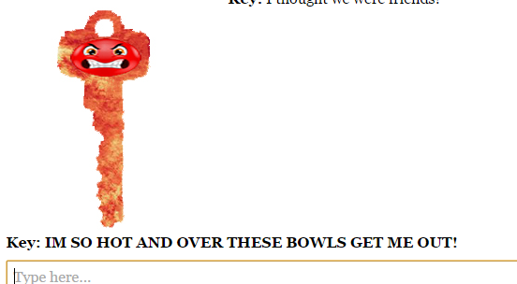

**After you incorrectly type in code (OPEN)**

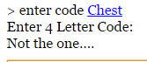

**After you correctly type in code (OPEN)**

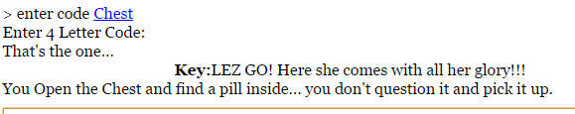

**After you eat the pill..**

